A000-Am,C-Costa Rica-Nicoya, Birmania Polychrome-Jaguar-Shaman effigy-Guanacaste-1000-1350 CE.

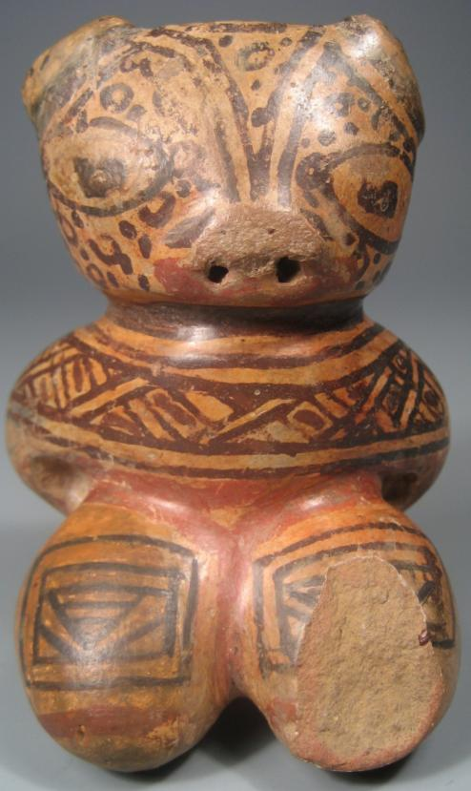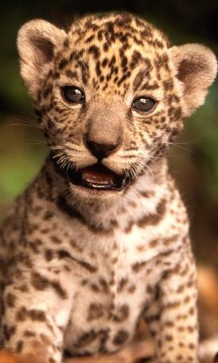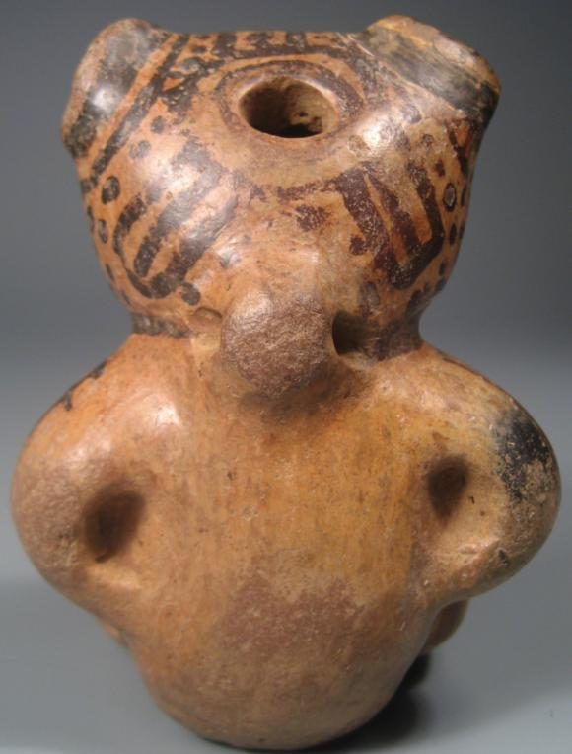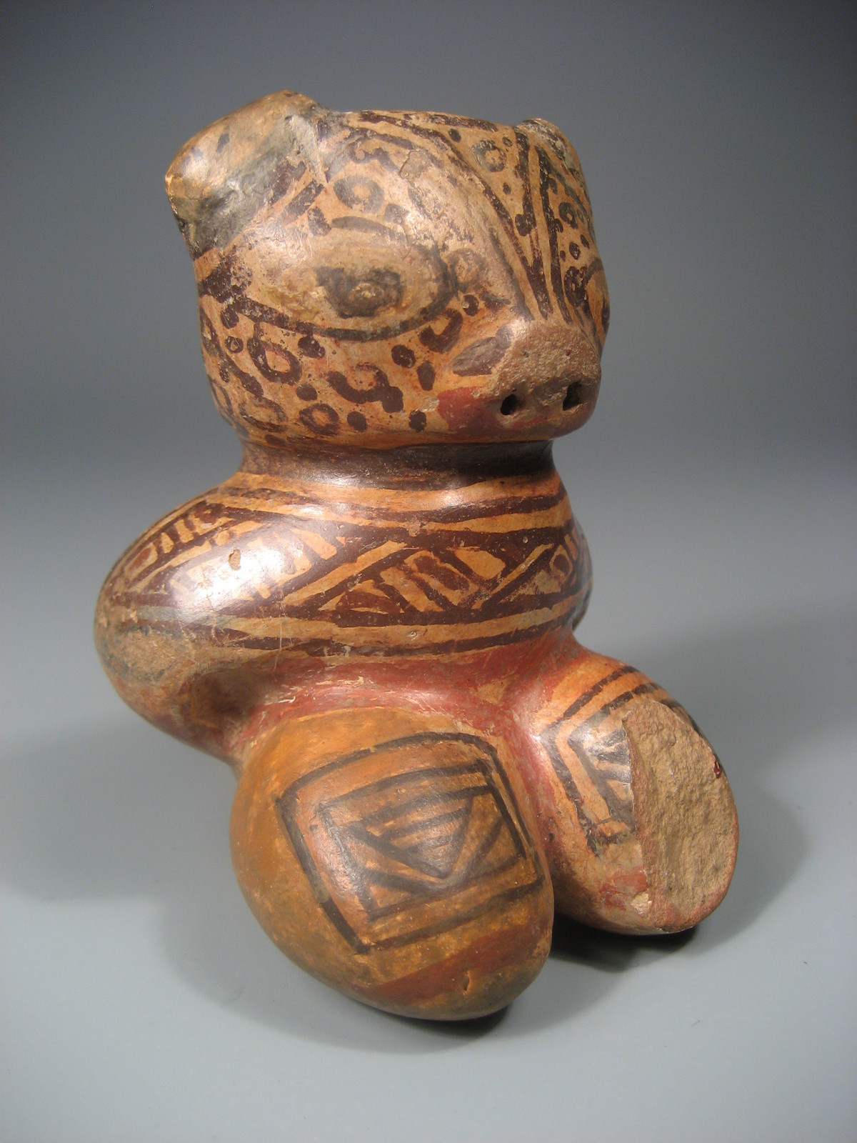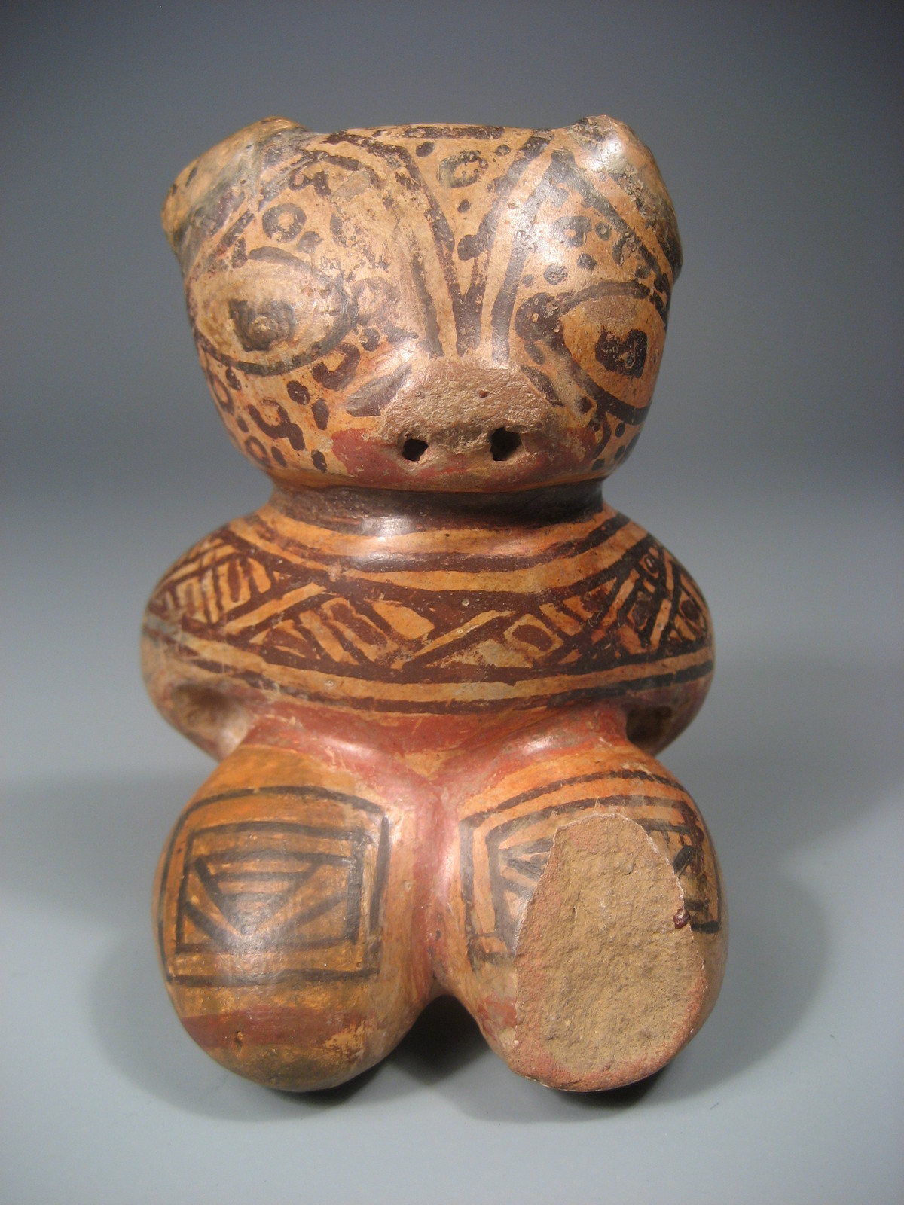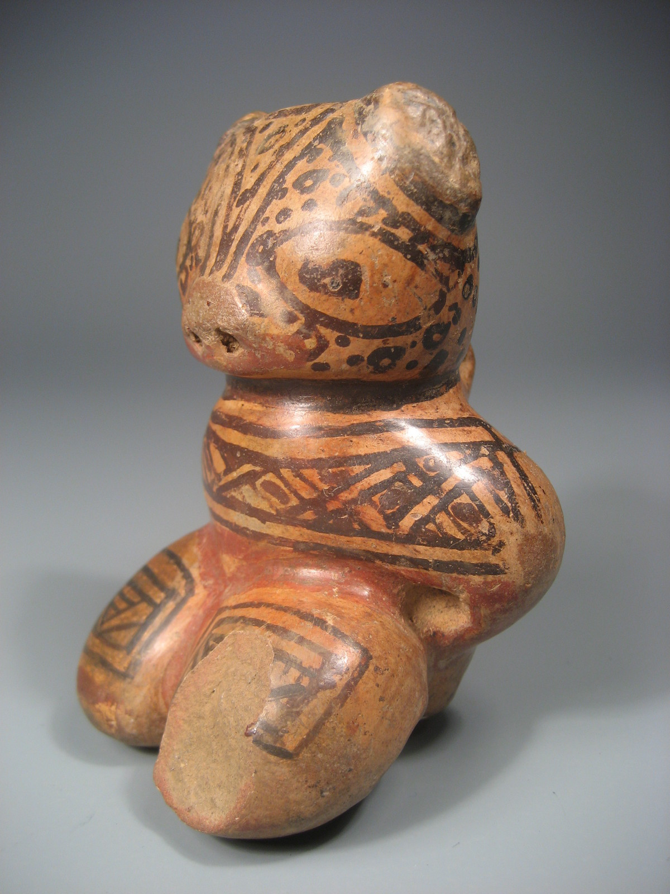

Figs. 1,3,4,5,6: Nicoya, Birmania Polychrome-Jaguar-Shaman effigy-Guanacaste, 1000-1350 CE;

Fig. 2. baby jaguar, after <http://www.photosshow.com/wp-content/uploads/2012/03/baby-jaguar.jpg>

Case No.: 14

**Accession No.**

**Formal Label:** Costa Rica-Nicoya, Birmania Polychrome-Jaguar-Shaman effigy-Guanacaste-1000-1350 CE.

**Display Description:**

This Nicoya, Birmania Polychrome-Jaguar-Shaman effigy-Guanacaste dates to 1000-1350 CE. The treatment of the jaguar head and the body in a stage of near complete transformation into a baby jaguar is similar to an example of a female Jaguar-Shaman from the Michael C. Carlos Museum (acc. no. 1991.4.24; Stone 2011: 83, Fig. 4.12). The stage of transformation of this figurine visually conveys that the animal spirit has metaphorically replaced the human spirit during the shamanic trance. What is being portrayed is therefore not a literalistic transformation but a spiritual one based on meditation and the shaman's identification with a young animal spirit. To accentuate this shamanic realization, the head is oversized --shamanic cephalocentrism, the eyes of the figurine are purposely larger than life suggesting enhanced spiritual vision, and the arms of the figurine are held behind the body as a human would. Another shamanic convention to emphasize the *openness* to spiritual realization is to accentuate the fontanel area of the crown of the head. In this example the figurine has a *hole* to indicate the fontanel. Two concentric circles around the fontanel hole have three bisected radiating rectangles as though there were some kind of headdress placed over the fontanel marking the shaman's spiritual entry point and as the seat of the feline alter ego (cf. Stone 2011: 80).. This hole also served as the necessary firing hole for the figurine. Perhaps this opening was also used as a whistle hole to be blown during the transformation ceremony, thereby uniting the shaman with this figurine's auditory power suggesting that the shamanic trance state had a sound component when the spirit being was being evoked. Furthermore, patterns painted in black are intended to emphasize varying elements of this transformation. For instance, the head of this Jaguar-shaman has the pattern of the jaguar's pelt--two literalistic curvilinear angular lines around the eye sockets on a background of circles and dots. The neck shows a literalistic necklace-like ring. Below this is an abstract band of interlocking upside-down chevrons, and on the legs are also upside-down chevrons within squares. The implication is that while the transformation is spiritually complete, it is not completely literalistic. And, why one might ask, is the shaman being transformed into a baby jaguar? The answer may well reside in the desire of the shaman to embody the young spirit of this most potent animal of the jungle both perhaps because he was young himself and perhaps because he desired to see the world with the clear vision of a baby's eyes.

**LC Classification:**

**Date or Time Horizon:**

**Geographical Area:**

**Map:**

**GPS coordinates:**

**Cultural Affiliation:**

**Media:**

**Dimensions:**

**Weight:**

**Condition:**

**Provenance:**

**Discussion:**

Nicoya, Birmania Polychrome-Jaguar-Shaman effigy-Guanacaste, 1000-1350 CE, rear view, showing hole in the fontanel area of the crown, the arms bent behind and the loop hole for attaching the figurine to a tether. This view of the crown also shows the concentric circles around the fontanel hole and three bisected rectangle radiating from these concentric circles as though there were some kind of headdress placed over the fontanel.

**References:**

Stone, Rebecca R. 2011*. The Jaguar within: shamanic trance in ancient central and south American Art*. Austin: University of Texas Press.

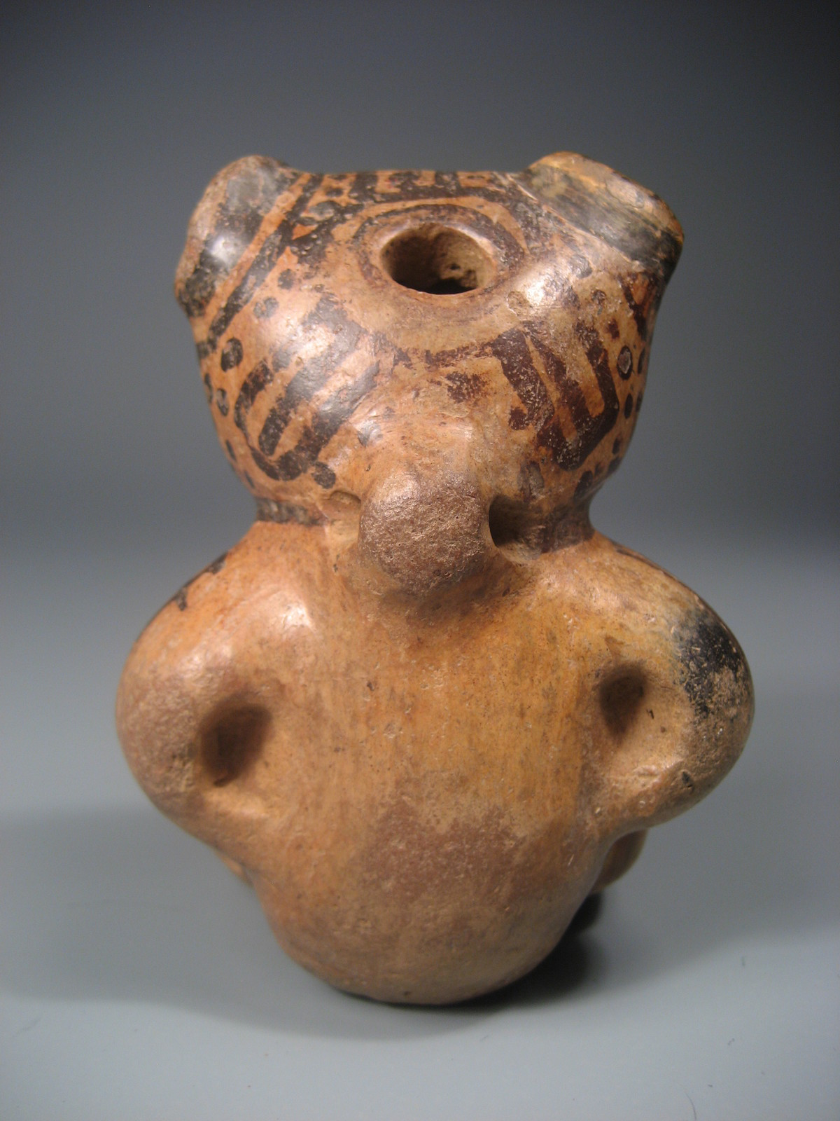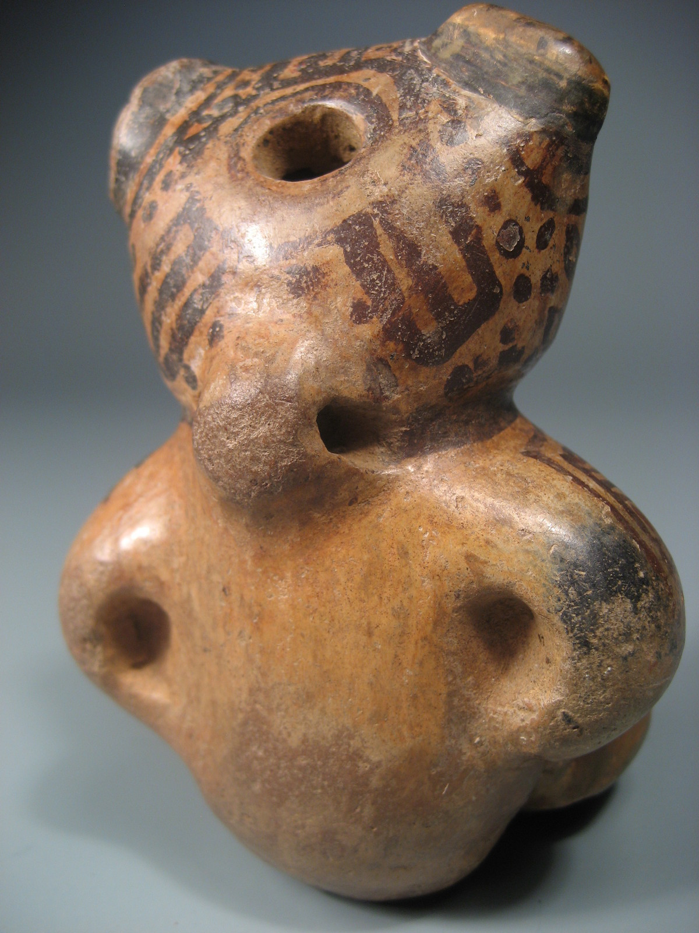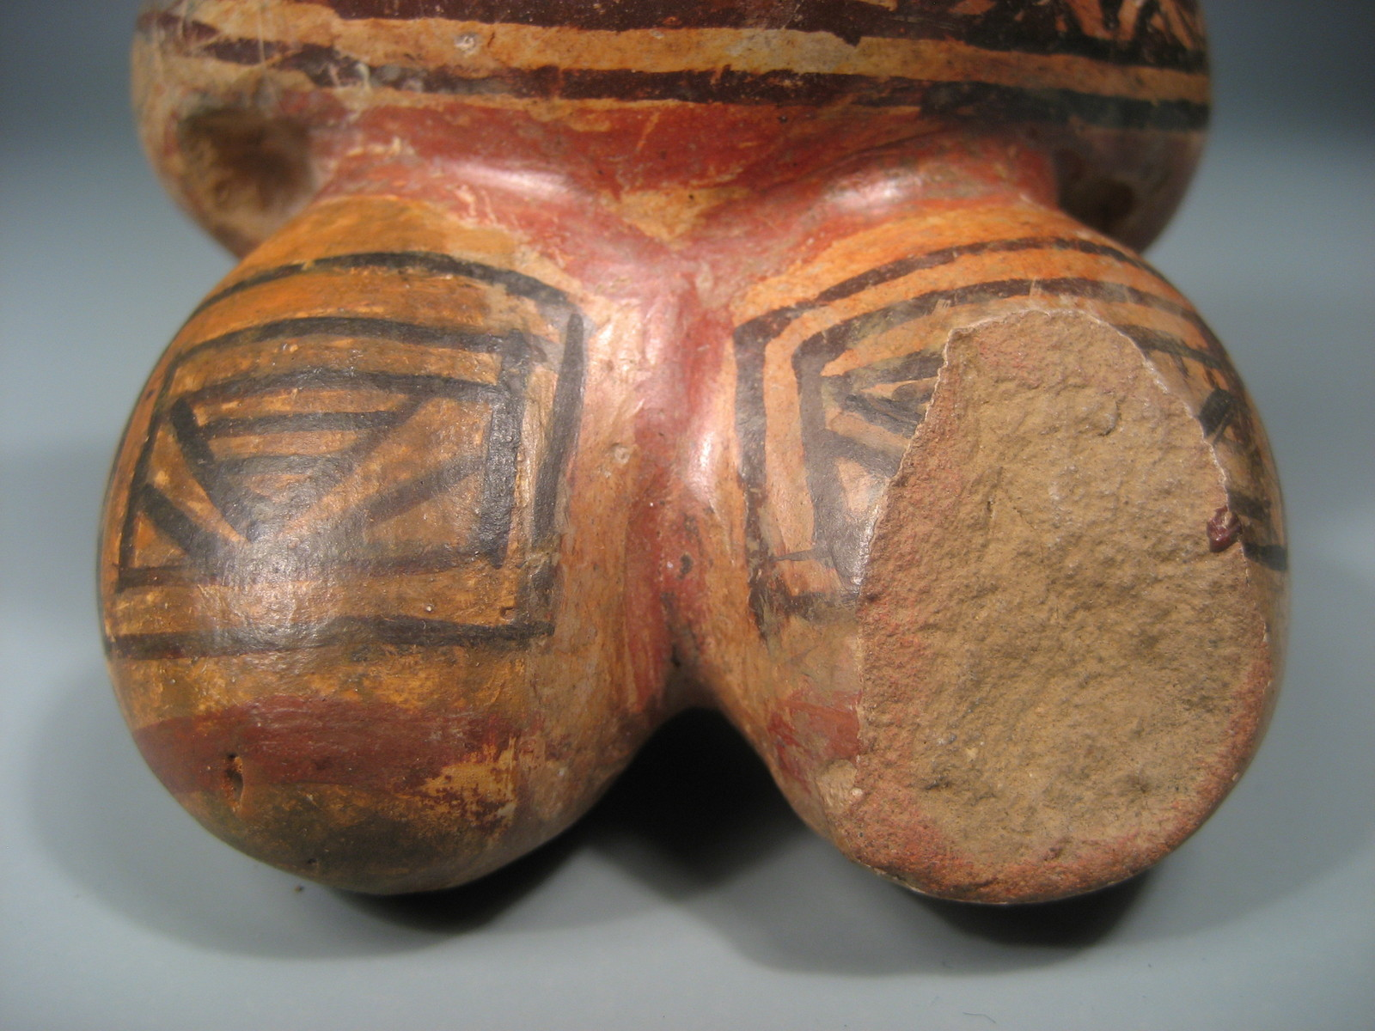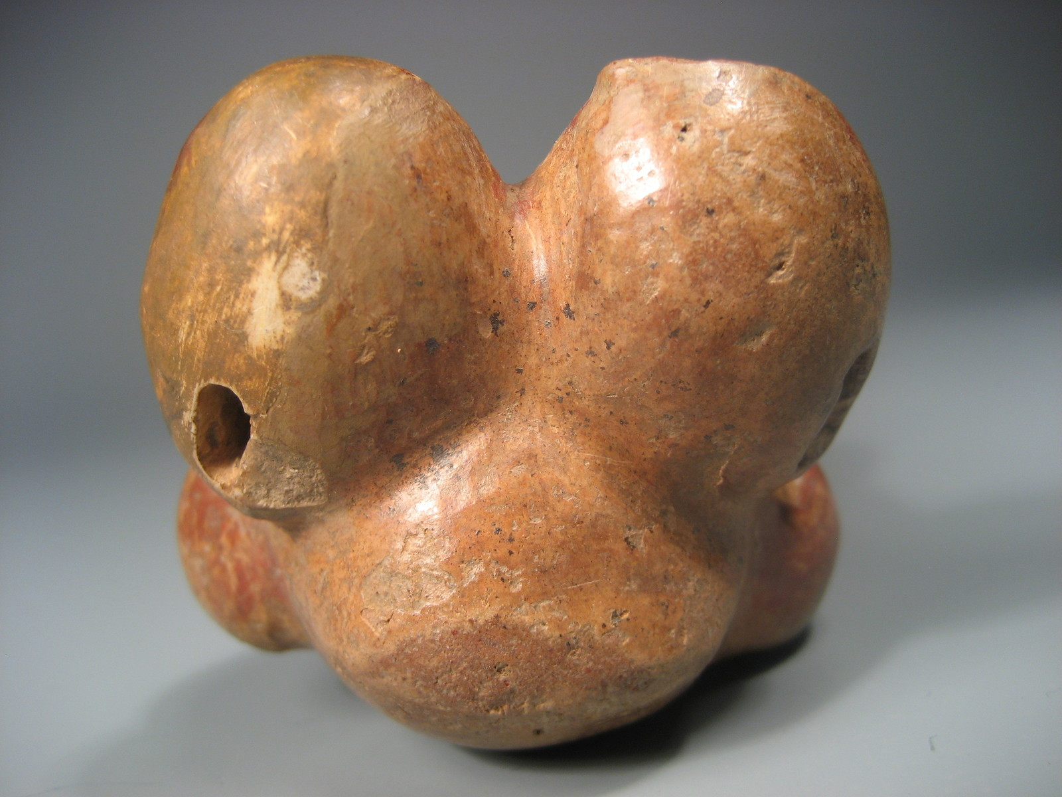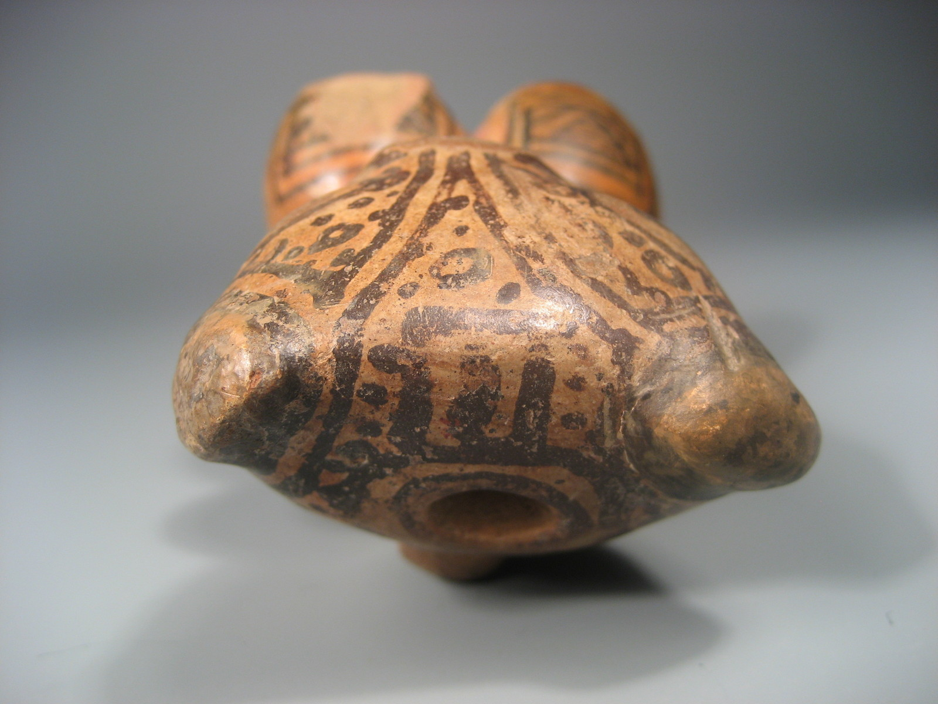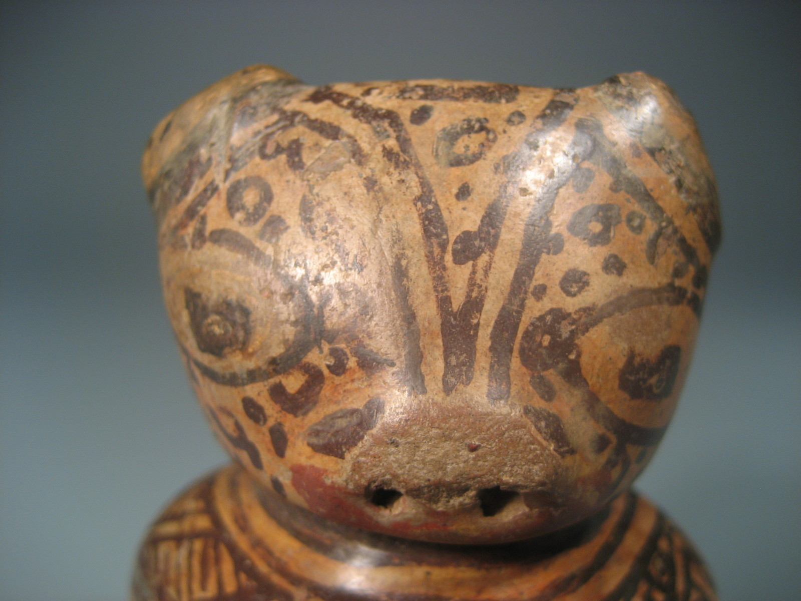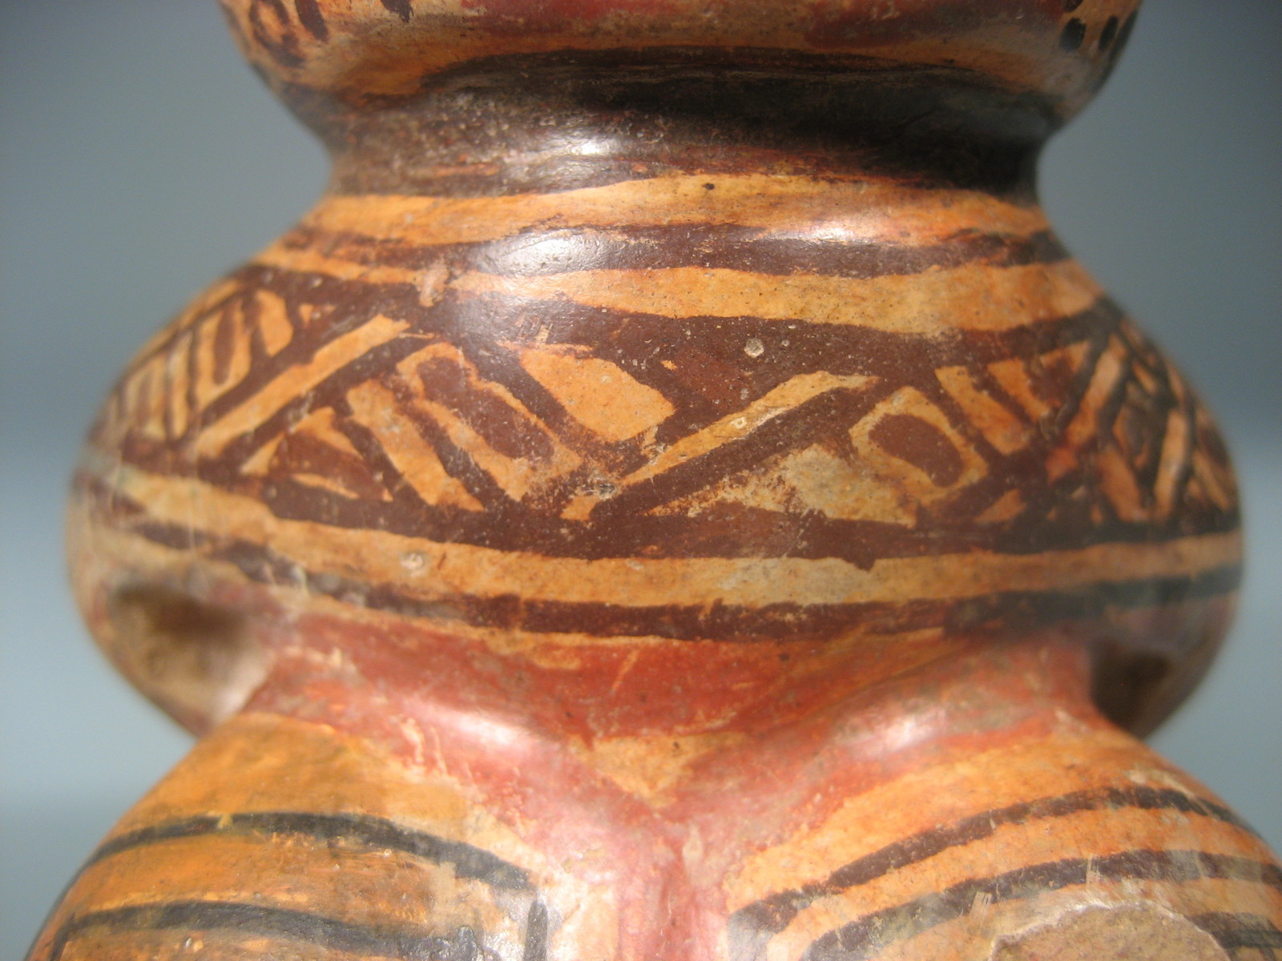

|  |
| --- |
| Payment details |
|  |
|  |
| Shipping details |
| **Ralph J Coffman Jr**  149 Atlantic Ave  Swampscott MA 01907-2427  United States |

## Order details

|  |  |  |  |
| --- | --- | --- | --- |
| **Item title** | **Available actions** | **Shipping & handling (estimated delivery*)** | **Price** |

[Printer version](http://payments.ebay.com/ws/eBayISAPI.dll?ViewPaymentStatus&transid=0&userloginid=802-867&orderid=124270379013&printerversion=true&itemid=150933893599)

|  |  |  |
| --- | --- | --- |
| Seller: | [**Member id** chavin](http://myworld.ebay.com/chavin) ( [**Feedback Score Of** 4265](http://feedback.ebay.com/ws/eBayISAPI.dll?ViewFeedback&userid=chavin)) | [Contact seller](http://contact.ebay.com/ws/eBayISAPI.dll?ShowCoreAskSellerQuestion&frm=3998&iid=221146989867&redirect=0&requested=chavin) |

|  |  |  |  |  |
| --- | --- | --- | --- | --- |
| Paid on Nov-02-12 via PayPal | | | | |
|  |  |  |  |  |

|  |  |  |  |  |  |  |  |
| --- | --- | --- | --- | --- | --- | --- | --- |
| [**Item Title:**Pre Columbian Costa Rica Chorotega Polychromed Jaguar Feline Figure 800-1200 AD**- opens in a new window or tab**](http://cgi.ebay.com/ws/eBayISAPI.dll?ViewItem&item=221146989867)  **Item Id:**221146989867 - Price: US $330.00  Quantity:1  **eBay note:**  Having a problem with this purchase? [We can help](javascript:;) | |  | | --- | |  | | |  |  | | --- | --- | | [Leave feedback](http://feedback.ebay.com/ws/eBayISAPI.dll?LeaveFeedbackShow&useridfrom=802-867&useridto=chavin&item=221146989867&transactid=1086110004012) |  | | | Economy Shipping: **US $8.00**  Estimated delivery: November 6 - November 20 | US $330.00 |

